Case Study

2012, McDonald’s and a Healthier Legacy
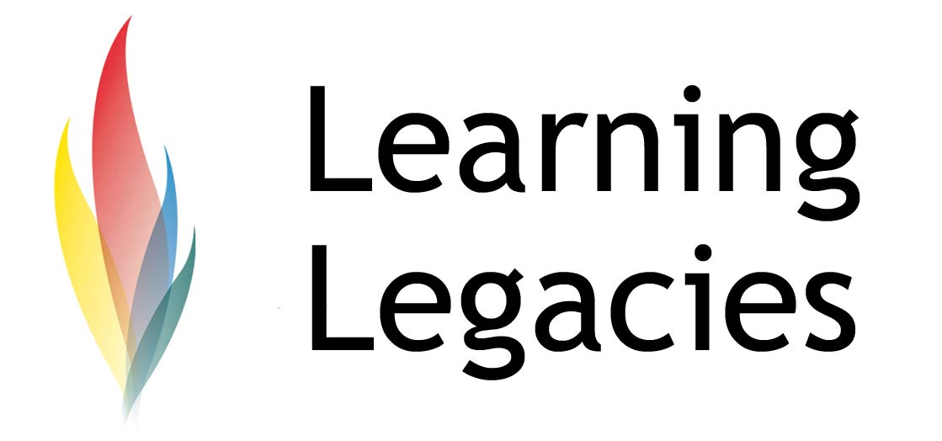

Hosting the 2012 Games AND the World’s Largest McDonalds: Great Catering or Nutritional Controversy?

McDonald's recently announced the renewal of its worldwide Olympic Partnership for the London 2012 Games – a relationship that has existed since 1968. McDonald’s is a long standing TOP Partner (the official sponsorship programme of the London 2012 Games), and its role as a London 2012 Games sponsor represents a continuation of the company’s close relationship with the IOC, with the associated acquisition of the exclusive marketing rights in the restaurant and food service category for the London Games. These exclusive rights were also awarded to McDonald’s for the 2006 Torino Olympic Winter Games, the 2008 Beijing Olympic Summer Games; the 2010 Vancouver Olympic Winter Games.

McDonald’s can claim the accolade of Official Restaurant of the London 2012 Olympic Games, in addition to its prestigious TOP Partner sponsorship. During the Games, thousands of athletes, coaches and spectators are projected to walk through the Golden Arches.

McDonald’s Chairman and Chief Executive Officer Jim Cantalupo stated that: "McDonald's has been a proud Olympic partner for nearly three decades because we believe in the spirit and ideals of the Games. As a global brand serving 47 million

customers every day, we share the same core principles of teamwork, excellence and being the best that make the Olympic Games a model of excellence for the world."

As a TOP sponsor, McDonald's rights include; use of the Olympic rings in global marketing activities; exclusive sponsorship opportunities with the 201 national Olympic teams based around the world; and, finally, status as the Official Restaurant Partner of the Olympic Games.

The Beijing Olympics proved a great marketing success for McDonald’s/ Peter Tan, McDonald's relationship partner in China commented that: "It is our honour and privilege to continue the McDonald's tradition of serving athletes from around the world a familiar taste of home. Our 580 McDonald's restaurants throughout China will also proudly deliver this special customer experience to our worldwide guests." The company plan to exploit the commercial opportunities offered by the London 2012 Games even further, with the construction of the world’s biggest McDonald’s restaurant in the Olympic Park in East London. The

30,000 sq m, two-floor restaurant will be able to

seat 1,500 people and is roughly half the length of an American football field. The restaurant is one of four McDonald’s that will be constructed in the area – including one in the Athlete’s Village itself. Throughout the duration of the Games, the restaurant is expected to employ a total of 470 staff, and to serve a whopping 50,000 Big Macs, 100,000 portions of fries and 30,000 milkshakes amongst a projected 1.75million meals that are likely to be sold during the Games.

Whilst McDonald’s are quick to site the benefits of the new giant restaurant, Olympic officials have

sought to reject claims that its construction clashes with the legacy goals of the Games. One of these goals is the promotion of healthy and active

lifestyles, an important step in challenging the rising epidemic of obesity that is exerting a strain on the British national health system. A controversy has arisen as McDonald’s food and beverages often contain high levels of fat, salt and sugar and can be considered detrimental to health.
ATHLETES SPEAK OUT

London 2012 will represent the 9th consecutive Games where McDonald's holds the title of official restaurant and carries the benefit of being the only branded food retailer in the Athlete’s Village that is responsible for feeding the athletes. As

Case Study

2012, McDonald’s and a Healthier Legacy

advancements in sports nutrition have developed significantly over the last few years, it is questionable to consider whether McDonald’s have the capacity or the right to claim that they can adequately provide athletes with the optimal nutritive needs that they require to sustain performance at elite levels. Certainly, the company has both fans and detractors amongst the athletes that participate in the Games.

Usain Bolt

Usain Bolt - the world's fastest man – ate Chicken McNuggets twice on the day that he achieved his 100m Gold medal winning performance in Beijing. Describing his preparation for the race, Bolt explained his schedule: 'I woke around 11am and decided to watch some TV and had some nuggets.

'Then I slept for a couple of hours more. Then I got some more nuggets and came to the track.'

Amir Khan

Former Olympian Amir Khan was more scathing in his opinions, however. The 2004 Team GB boxing silver medallist commented that: 'It is clearly sending the wrong signal to kids and young people. If we want them to be healthy and educate them to eat healthily, we need to think about approaching them in a different way, especially around sport. The Olympics are a great

opportunity to show young people what types of food they need in different aspects of their lives. I think this is a mistake.'

McDonald’s UK chief executive, Jill McDonald, commented that: 'To be involved in the greatest sporting event on earth is hugely exciting. We want everyone who visits our Olympic Park restaurants to have the best possible experience.' However, the best possible experience, as conceptualised by McDonald’s, does not appear to correlate with the legacy goals of the Games.

LEGACY GOALS OF THE LONDON 2012 GAMES

The London 2012 Sustainability Plan (2nd Edition, December 2009) set out the legacy goals of the London 2012 Games. Given that the legacy impact of the 2012 Games formed a central aspect of the winning host city bid for London, it is interesting that the healthy living aspect of the proposed legacy must now sit alongside the extensive promotion of a fast food outlet.

Promotion of healthy lifestyles, including healthy eating, is set out clearly as a legacy goal:

Living healthy lifestyles, within the resources of the planet, is an essential element of working towards a one planet 2012. Advances in public health mean that some of the greatest health benefits that we can achieve are those that are within our own control: eating well, engaging in physical activity,

Case Study

2012, McDonald’s and a Healthier Legacy

and living in a healthy environment are among the most important things we can do to improve our quality of life, our well-being and our happiness. As the world’s pre-eminent festivals of sporting excellence, the Olympic and Paralympic Games offer huge opportunities to inspire and promote sports participation, play and other forms of physical activity, and other elements of healthy living.’

SUMMARY
The overall legacy impact of the Games covers financial, economic, social and environmental factors. In today’s economic climate, one might argue that investments in mega-restaurants and sponsorship deals generated by McDonald’s provide a vital boost to the economy, and that individuals have a responsibility to exercise moderation in the food choices that they make.

However, detractors could equally argue that the selection of McDonalds as the Official Restaurant of the Games, including the construction of the mega-restaurant in the Olympic Park and Athletes Village, constitutes a thorn in the side of those aiming to meet the legacy objectives of the London Games.

FURTHER INFORMATION

The London 2012 Sustainability Plan (2nd Edition, December 2009)
http://www.london2012.com/documents/locog-publications/london-2012-sustainability-plan.pdf
DISCUSSION
- If a stated legacy of the 2012 Games is to improve the health of the nation, why do you think that the IOC chose a fast food outlet as a sponsor?
- Lucrative sponsorship contracts generate profits. Without these profits, legacy plans could not be executed. On this basis, can McDonald’s sponsorship be considered to align with 2012 legacy goals?
- How much does the treatment of obesity cost to the UK taxpayer per annum?
- Do you think that the 2012 Games will impact your nutritional choices? Please explain your answer.
- Does the IOC’s choice of McDonald’s as a sponsor sway your interest in consuming junk food?
- If you were part of the Government, how would you go about improving the nations’ health (in terms of the nutritional choices that they make)?

Case Study

2012, McDonald’s and a Healthier Legacy

Case Study

2012, McDonald’s and a Healthier Legacy

This resource was produced as part of the 2012 Learning Legacies Project managed by the HEA Hospitality, Leisure, Sport and Tourism Subject Centre at Oxford Brookes University and was released as an Open Educational Resource. The project was funded by HEFCE and part of the JISC/HE Academy UKOER programme. Except where otherwise noted above and below, this work is released under a Creative Commons Attribution only licence.

Exceptions to the Licence
The name of Oxford Brookes University and the Oxford Brookes University logo are the name and registered marks of Oxford Brookes University. To the fullest extent permitted by law Oxford Brookes University reserves all its rights in its name and marks, which may not be used except with its written permission. The JISC logo is licensed under the terms of the Creative Commons Attribution-Non-Commercial-No Derivative Works 2.0 UK: England & Wales Licence. All reproductions must comply with the terms of that licence.

The Higher Education Academy logo is owned by the Higher Education Academy Limited and may be freely distributed and copied for educational purposes only, provided that appropriate acknowledgement is given to the Higher Education Academy as the copyright holder and original publisher.

Reusing this work
To refer to or reuse parts of this work please include the copyright notice above including the serial number. The only exception is if you intend to only reuse a part of the work with its own specific copyright notice, in which case cite that.

If you create a new piece of work based on the original (at least in part), it will help other users to find your work if you modify and reuse this serial number. When you reuse this work, edit the serial number by choosing 3 letters to start (your initials or institutional code are good examples), change the date section (between the colons) to your creation date in ddmmyy format and retain the last 5 digits from the original serial number. Make the new serial number your copyright declaration or add it to an existing one, e.g. ‘abc:101011:011cs’.

If you create a new piece of work or do not wish to link a new work with any existing materials contained within, a new code should be created. Choose your own 3-letter code, add the creation date and search as below on Google with a plus sign at the start, e.g. ‘+tom:030504’. If nothing comes back citing this code then add a new 5-letter code of your choice to the end, e.g.; ‘:01lex’, and do a final search for the whole code. If the search returns a positive result, make up a new 5-letter code and try again. Add the new code your copyright declaration or add it to an existing one.

Case Study

Ambush marketing and the Games

WOMENS PARTICIPATION IN THE OLYMPIC GAMES

The London 2012 Sustainability Plan (2nd Edition, December 2009)

